Beginning Earth Science Inventory

- Write in proper symbols the basic metric unit for length, mass and volume.

- Explain the difference between Mass and Weight.

- Which measurement is most closely related to size: mass, volume, or length.

- What is the difference between an Observation and an Inference.

- Define Density and predict which phase of matter usually has the highest and which has the lowest density.

- Why did #5 say usually?

- What does and does not affect density?

- What are units of density?

- Using a Mass- Volume graph predict:
- The density of a substance.
- How densities of various substances compare.
- A Mass of a given volume.
- A Volume of a given mass.
- The ability to float in water or not.

- 3000000 = ___________________

- 5x10³ = _____________________
- Determine the order of fluid density in a column? 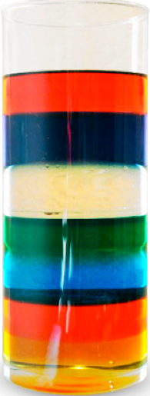

- Be able to plot any data set on a X-Y axis knowing what variable goes on the horizontal axis.

- What are the major fields of Study in Earth Science?

